**FPT ACADEMY INTERNATIONAL**



## FPT – APTECH COMPUTER EDUCATION

**ROCK PARADISE**

|  |  |  |  |
| --- | --- | --- | --- |
| **Center Name** | | FPT – Aptech – HCM2  Address: 21Bis Hậu Giang, Phường Tân Sơn Nhất, TP. HCM. | |
| **Instructor** |  | Ms. Le Mong Thuy |  |
| **Class** |  | T3.2502.E0 |  |
| **Group** |  | 3 |  |
| **Group members** | | **Name** | **Student ID** |
|  |  | Tang Thien Tan | Student1634690 |
|  |  | Phan Minh Huy | Student1634681 |
|  |  | Pham Quoc Tuan | Student1634695 |
| **Duration** | Start date | **23-Jul-2025** |  |
| End date | **23-Aug-2025** |  |

**This is to certify that**

**Mr.:**

Tang Thien Tan

Phan Minh Huy

Pham Quoc Tuan

**has successfully designed & developed:**

eProject: Rock Paradise website

**Authorized Signature:**

Table of content

**Acknowledgments**

We would like to express our sincere gratitude to FPT Aptech and the eProject team for providing a dynamic, creative, and inspiring learning environment that gave our team the opportunity to carry out this project.

Throughout the working process, we received valuable support from our lecturers and school staff — those who not only imparted professional knowledge but also inspired and motivated us to overcome every challenge. Their dedication and seriousness were a great source of encouragement that helped us complete the project effectively and practically.

We also deeply appreciate the serious, united, and enthusiastic working spirit of each team member. Everyone contributed effort, time, and creative ideas to build a complete product together. Despite facing technical difficulties, time constraints, and pressure, we all strived continuously, showing strong determination toward this project.

This eProject is not just an academic assignment, but a real-world experience that helped us grow in mindset, skills, and teamwork spirit. It marks an important milestone in our learning journey at FPT Aptech — one that we will always remember and cherish.

Once again, we sincerely thank everyone who accompanied and supported us throughout the project.

**Project Summary**

The goal of this eProject is to design and develop a **Single-Page Application (SPA)** and **responsive website** for **Rock Paradise** — a leading online retailer specializing in crystals and gemstones sourced ethically from around the world.

The website will showcase Rock Paradise’s diverse product offerings, including **tumbled gemstones, healing crystals, clusters, rough and raw stones, towers, spheres**, and more. It will serve both collectors and individuals seeking spiritual or wellness benefits from natural stones.

Key features of the website include:

* A visually appealing and user-friendly interface.
* Compatibility across all major browsers (Chrome, Internet Explorer, Firefox, etc.).
* Responsive design for optimal viewing on desktops, tablets, and mobile devices.
* Clear presentation of product categories and ethical sourcing values.
* Seamless navigation and engaging content to enhance user experience.

This project aims to reflect Rock Paradise’s brand identity, commitment to sustainability, and passion for high-quality natural stone products — offering customers an immersive and trustworthy online shopping experience.

**Project Requirement Analysis**

1. **Project Objective**

The goal is to design a Single Page Application (SPA) that is visually appealing, responsive across devices, and provides smooth navigation. The portal will showcase various jewelry items made from precious crystals and offer interactive features for users.

1. **Website Structure and Content**

***Header Section.***

* Display a logo representing the brand.
* Include images of diamonds, crystals, and gemstones.
* Show a visitor counter at the top-right corner beside the logo.

***Main Navigation Menu.***

* Categories: Diamond, Quartz, Ruby, Sapphire, Emerald.
* Top Selling Items: A separate section for bestsellers.
* Gallery: A visual showcase of jewelry images.
* Offers: Promotions and discounts with detailed descriptions.
* About Us, Contact Us, FAQ, Site Map.

***Product Listing Page.***

* Display jewelry items under each crystal category.
* Provide filter**s** for:
  + - Brand (e.g., Swarovski, Tiffany, Pandora).
    - Color.
    - Size.
    - Price.
    - User Ratings.
* Allow users to submit ratings and filter by rating score.

***Footer Section.***

* Implement a scrolling ticker showing current date, time, and user location (using HTML5 Geolocation).
* Include links to About Us, Contact Us, FAQ, and Site Map.

1. **Design Requirements**

|  |  |
| --- | --- |
| **Component** | **Design Specification** |
| Fonts | Elegant, readable, and consistent across pages |
| Color Scheme | Uniform and harmonious throughout the website |
| Visual Effects | Hover and click color changes on menu items; fade in/out transitions |
| Responsiveness | Fully responsive layout for desktop, tablet, and mobile |
| Imagery | High-quality visuals of gemstones and jewelry |

1. **Advanced Functionalities**

* **Visitor Counter**: Display number of site visitors.
* **Scrolling Ticker**: Show live date, time, and location.
* **Interactive Menus**: Color change on hover/click; fade animations.
* **Smart Filtering**: Filter products by brand, color, size, and rating.
* **User Ratings**: Allow rating input and filtering by rating.

1. **Additional Pages**

* **About Us**: Includes company description, email, address, and contact number.
* **Contact Us**: Contact form or direct contact details.
* **FAQ**: Frequently asked questions.
* **Site Map**: Overview of website structure.

**Project Design**

After reviewing the project analysis, our team decided to design the website as following pages:

1. ***Homepage***: There is a search bar to search for products, display promotional information, best-selling products and introduce.
2. ***Product***: Displays all available products based on the Category category (Diamond, Quartz, Ruby, Sapphire, Emerald). In the above categories, products can be filtered by name, brand, color, user rating, size and price.
3. ***Blog***: Display articles, news, promotion,…
4. ***About Us***: Display the information of the company, client’s review and about us.
5. ***Contact Us***: Display the address of the company, Map and allow customers to request any information they want to Rock Paradise.
6. ***Sign In/ Sign Up***: Allow users sign up or sign in to the website.
7. ***Shopping Cart***: Users can select multiple products and add them to the cart, review them before checkout, make adjustments directly in the cart, enter promotional codes before payment, and choose payment methods and delivery addresses.

**Task sheet review 1**

|  |  |  |  |  |  |  |  |
| --- | --- | --- | --- | --- | --- | --- | --- |
| **Project Ref. No.:**  **eP/Advertisement Portal Management**  **System/01** | | **Project Title:** | **Activity Plan Prepared By:** | **Date of Preparation of Activity Plan:** | | | |
| **Sr.**  **No.** | **Task** | **Actual**  **Start**  **Date** | **Actual Days** | **Team**  **Mate Names** | **Status** |
| 1 | Problem Statement | ROCK PARADISE | Thien Tan | 25-July-25 | 2 | Tan | Completed |
| 2 | Analysis Project requirements about the website. | 25-July-25 | 2 | Tan | Completed |
| 3 | The scope of the work | 25-July-25 | 2 | Huy | Completed |
| 4 | Architecture and design of the system | 25-July-25 | 2 | Huy | Completed |
| 5 | Diagram of the website | 25-July-25 | 2 | Tuan | Completed |
| 6 | Task Sheet | 25-July-25 | 2 | Tuan | Completed |

|  |  |
| --- | --- |
| **Date:** | |
| Signature of Instructor:  **Ms. Le Mong Thuy** | Signature of Team Leader:  **Tang Thien Tan** |

**User Flow**

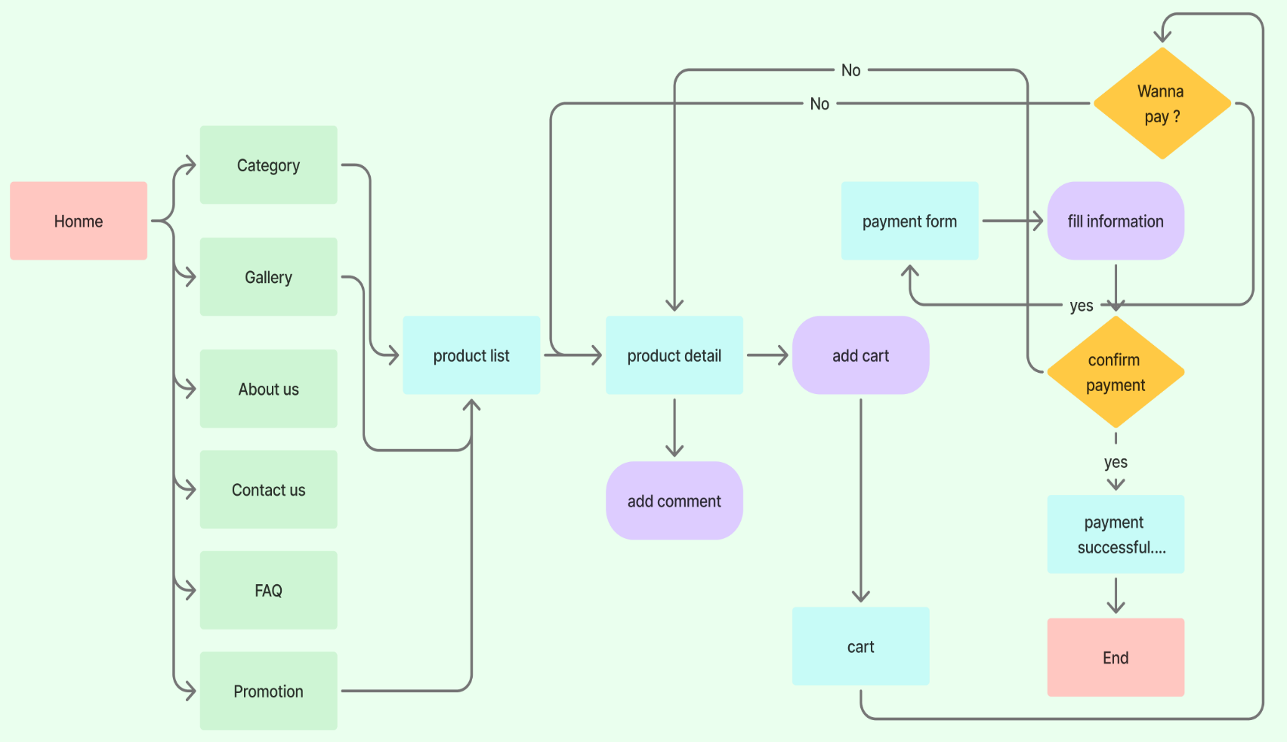

*Picture 1. Figma UserFlow Diagram.*

**Site Map**

*Picture 2. Figma SiteMap Diagram.*

**Wire Frame**

1. Home pages.

*Picture 3. Figma Design HomePage.*

1. Product list.

*Picture 4. Figma Design ProductList.*

1. Product detail

*Picture 5. Figma Design ProductDetail.*

1. Shopping cart

*Picture 6. Figma Design ShoppingCart.*

**Task sheet review 2**

|  |  |  |  |  |  |  |  |
| --- | --- | --- | --- | --- | --- | --- | --- |
| **Project Ref. No.:**  **eP/Advertisement Portal Management**  **System/01** | | **Project Title:** | **Activity Plan Prepared By:** | **Date of Preparation of Activity Plan:** | | | |
| **Sr.**  **No.** | **Task** | **Actual**  **Start**  **Date** | **Actual Days** | **Team**  **Mate Names** | **Status** |
| 1 | User Flow | ROCK PARADISE | Thien Tan | 31-July-25 | 1 | Tan | Completed |
| 2 | Site Map | 31-July-25 | 2 | Huy | Completed |
| 3 | Wire Frame | 31-July-5 | 2 | Tuan | Completed |

|  |  |
| --- | --- |
| **Date:** | |
| Signature of Instructor:  **Ms. Le Mong Thuy** | Signature of Team Leader:  **Tang Thien Tan** |

**Website Description**

* 1. Home Page

**Design Style:** The website has a modern, luxurious design with a neutral color palette (brown, white, gray) as the primary theme, highlighting the beauty of the jewelry products. The layout is clear and easy to navigate.

**Homepage Content:**

* **Header:**
  + The "ROCKPARADISE" brand logo is in the top-left corner.
  + The main navigation menu includes: About Us, Contact Us, FAQ, Gallery, and Category.
  + A shopping cart icon is in the top-right corner.
* **Main Banner (Hero Section):**
  + A large banner with a refined jewelry image and the text: "Discover Rare Gemstones - Elegant. Timeless. Unique."
  + An "Explore" button invites users to learn more.
* **Product Categories:**
  + This section introduces the types of gemstones and jewelry brands offered by Rockparadise.
  + The categories are presented as buttons, including: Diamond, Quartz, Ruby, Sapphire, Emerald, Topaz, Amethyst, Opal, Tiffany, Swarovski, and Pandora.
* **"Best Seller" Section:**
  + Displays four of the most popular products, each with a clear image, product name, price, and a "Detail" button to view specific information.
  + Product examples:
    - Tiffany White Diamond VVS1 ($5,300 USD)
    - Pandora Red Ruby Oval ($3,200 USD)
    - Swarovski Royal Blue Sapphire Emerald Cut ($4,890.75 USD)
    - Tiffany Princess Cut Diamond ($3,950 USD)
* **"Promotion" Section:**
  + Displays four products currently on promotion.
  + Product examples:
    - Swarovski Blue Sapphire Sri Lanka ($2,750.5 USD)
    - Tiffany G Color Diamond Round ($2,100 USD)
    - Pandora Deep Red Burmese Ruby ($5,600 USD)
    - Swarovski Teal Sapphire Oval Cut ($2,400 USD)
* **"Explore Our Gallery" Section:**
  + Presents a large image gallery featuring the main gemstones: Diamond, Quartz, Ruby, and Sapphire.
  + Each gemstone has a brief description of its notable characteristics. For example, Ruby is called the "King of Gems."
* **Footer:**
  + **Brand logo** in the bottom-left corner.
  + **Social media icons:** Facebook, Twitter, Instagram, and LinkedIn.
  + **Contact Information:** Address, phone number, and email. The detailed address is: 88 Lê Lợi, District 1, HCMC, with a Google Map link.
  + **Navigation menu:** Contact Us, About Us, FAQ, Category, and Gallery.
  + **Other information:** Current date and time, and visitor count.

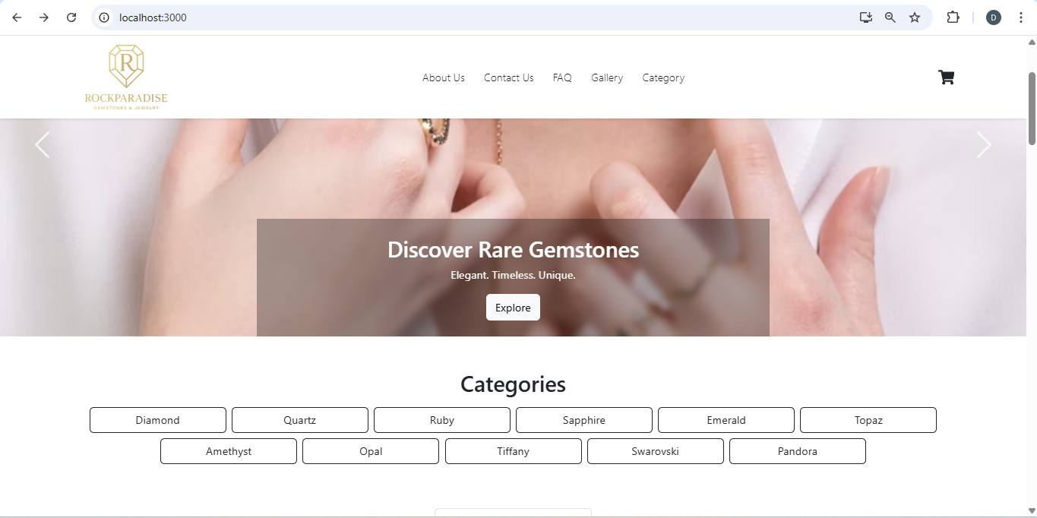

*Picture 7. Screenshot website HomePages.*

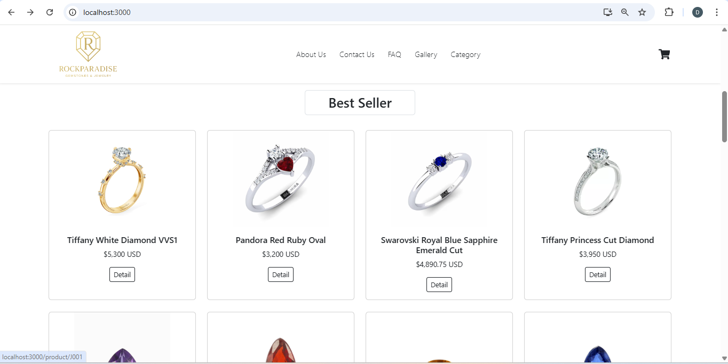

*Picture 8. Screenshot website HomePages.*

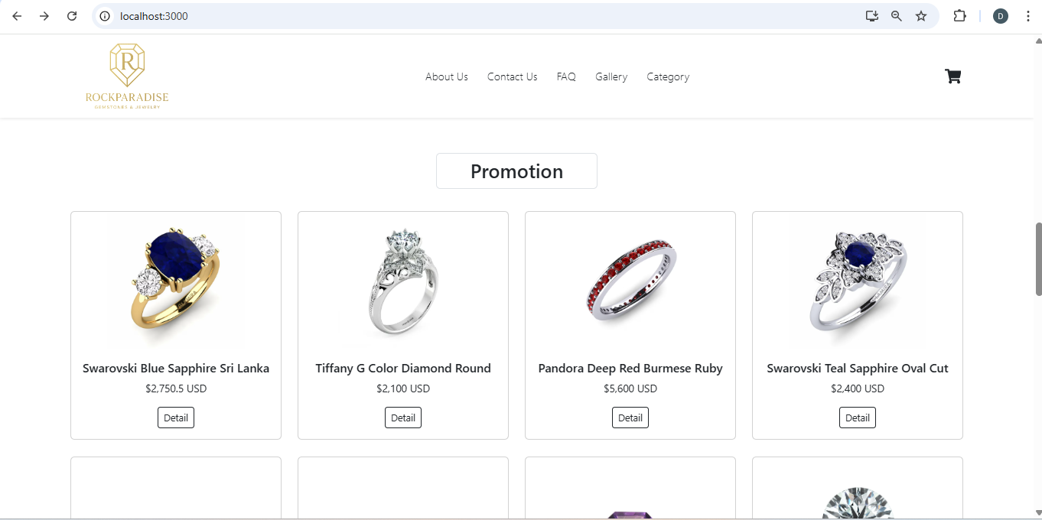

*Picture 9. Screenshot website HomePages.*

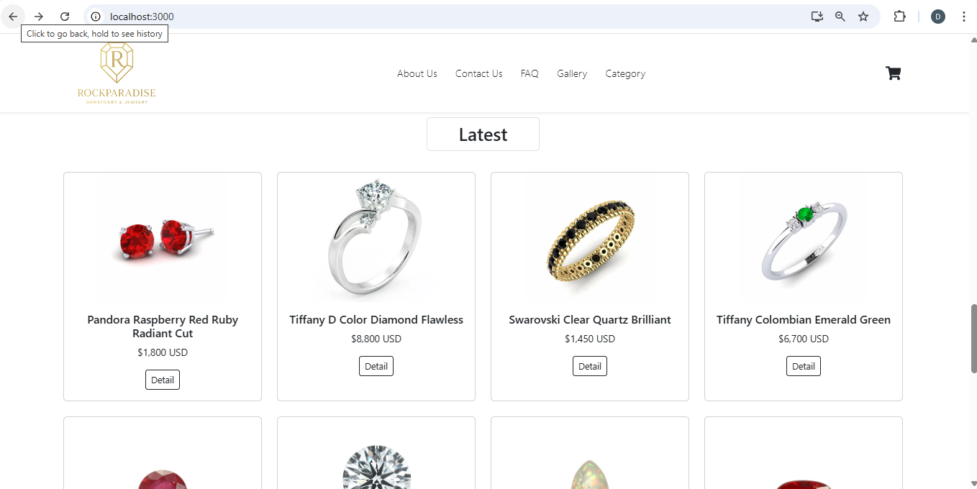

*Picture 10. Screenshot website HomePages.*

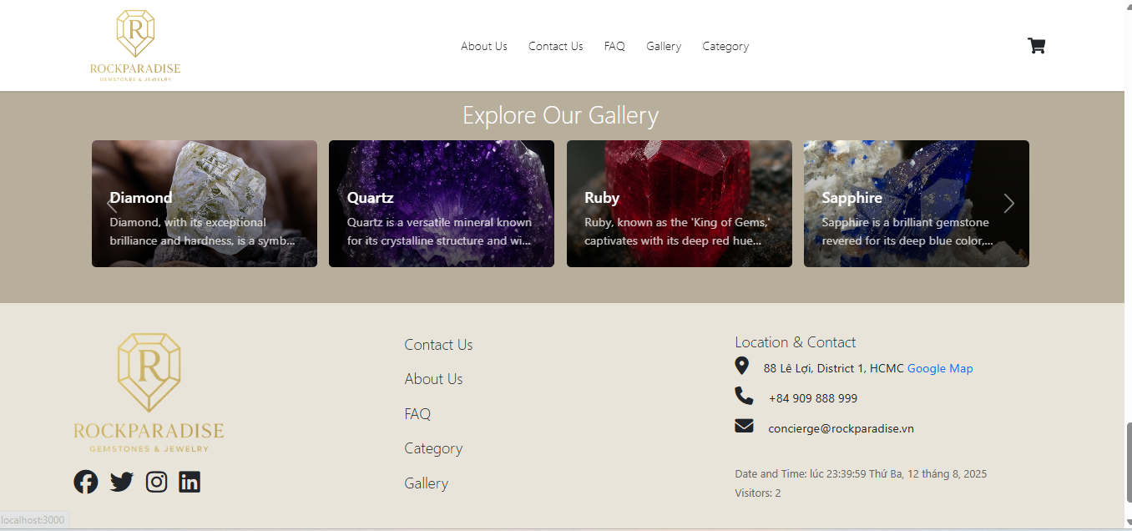

*Picture 11. Screenshot website HomePages.*

* 1. Category

**Design Style:** The page has a clean, minimalist layout, making it easy for users to find and view products.

**Structure:**

* **Category Navigation Bar:**
  + Located on the left side of the page.
  + Displays the main product categories as buttons.
  + The currently selected category (in this case, "Diamond") is highlighted, showing the user their current location.
  + Other categories include: Quartz, Ruby, Sapphire, Emerald, Topaz, Amethyst, Opal, Tiffany, Swarovski, and Pandora.
* **Product Display Area:**
  + Occupies the majority of the page on the right.
  + The title "Products in Diamond" displays the name of the current category.
  + A "Default Sort" dropdown menu allows users to sort the products.
  + Products are presented in a grid layout with basic information:
    - Product image.
    - Product name (e.g., Tiffany White Diamond VVS1).
    - Product price (e.g., $5,300 USD).
    - A "Detail" button to view more specific information about the product.

**Function of the "Detail" Button (Product Detail Page)**

When a user clicks the "Detail" button on any product from the category page, they are directed to the Product Detail Page.

**Specific Example:** Clicking "Detail" on the "Tiffany White Diamond VVS1" product displays the following:

**Page Structure:**

* **Back Button:** A " Back" button at the top-left corner allows the user to return to the previous category page.
* **Main Product Display Area:**
  + **Large Image:** A high-resolution image of the product is displayed.
  + **Thumbnails:** A series of smaller images below the main one allows users to view the product from different angles.
* **Detailed Product Information:**
  + **Product Name:** "Tiffany White Diamond VVS1"
  + **Attributes:**
    - **Type:** Diamond
    - **Color:** White
    - **Brand:** Tiffany
    - **Size:** 1.25 ct
    - **Price:** $5,300
  + **Description:** A short text block describing the product, for example: "Natural white diamond, VVS1 clarity, excellent cut."
  + **Purchase Button:** A dark brown "Add to Cart" button for purchasing the product.
* **"You May Also Like" Section:**
  + Located at the bottom of the page.
  + Displays a list of other related or recommended products based on the one the user is viewing.
  + Each suggested product also includes an image, name, price, and a "Detail" button.
* **"View More" Button:** Located below the suggested products, allowing users to see more similar items.

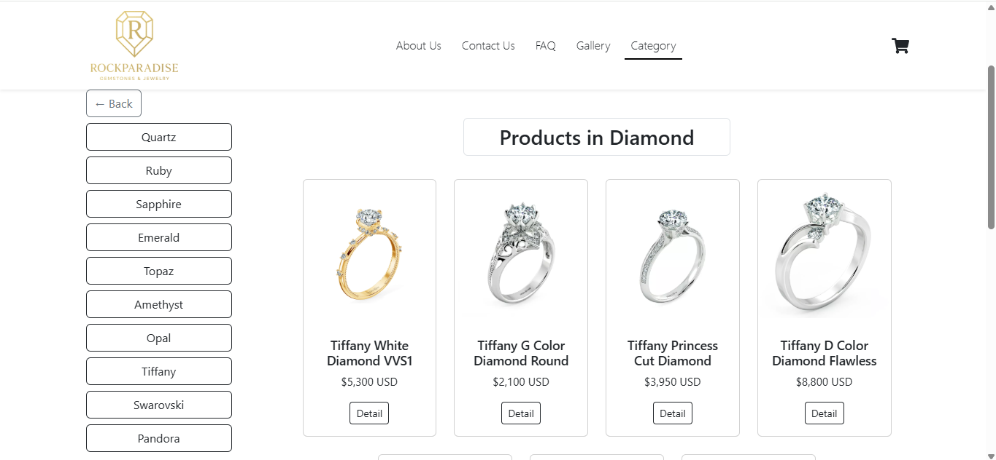

*Picture 12. Screenshot website Category.*

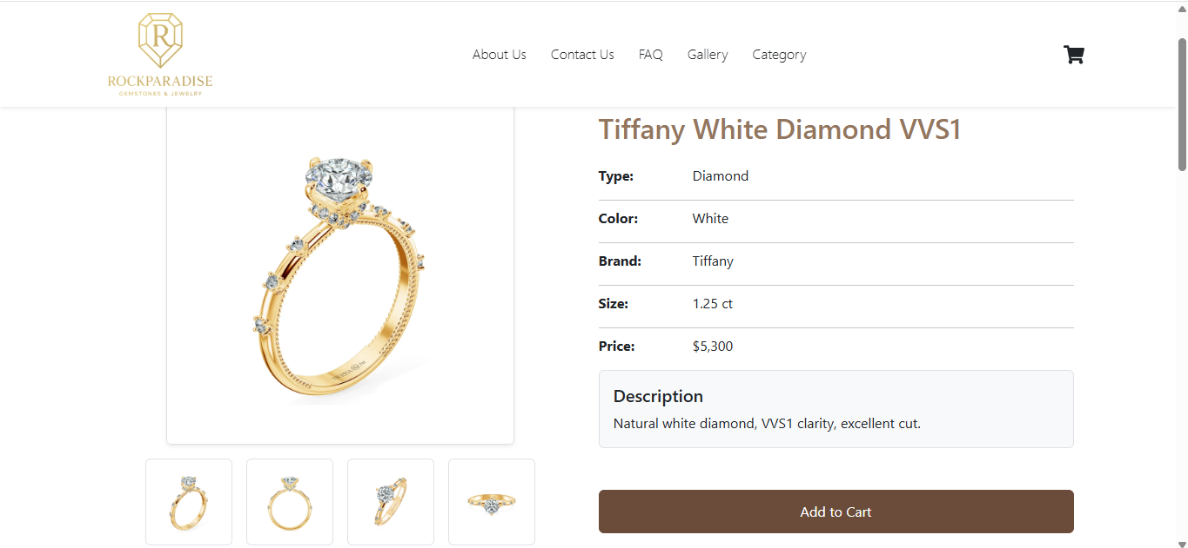

*Picture 13. Screenshot website Category when click “Detail”.*

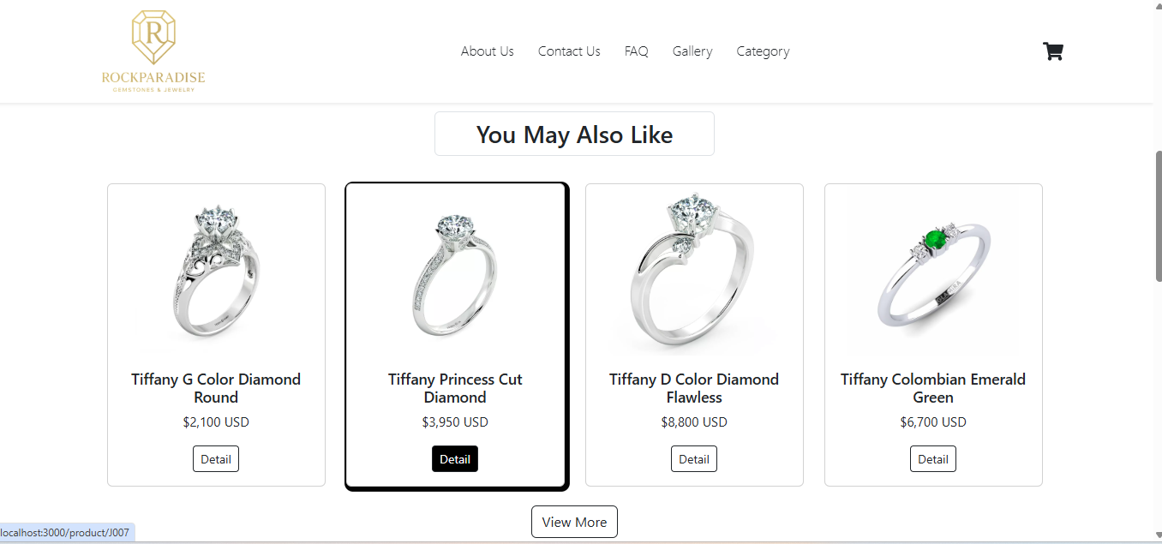

*Picture 13. Screenshot website Category when click “Detail”.*

* **Click the basket to show the mini cart:**

You can adjust products in mini cart, can remove from cart, adjust product quantity

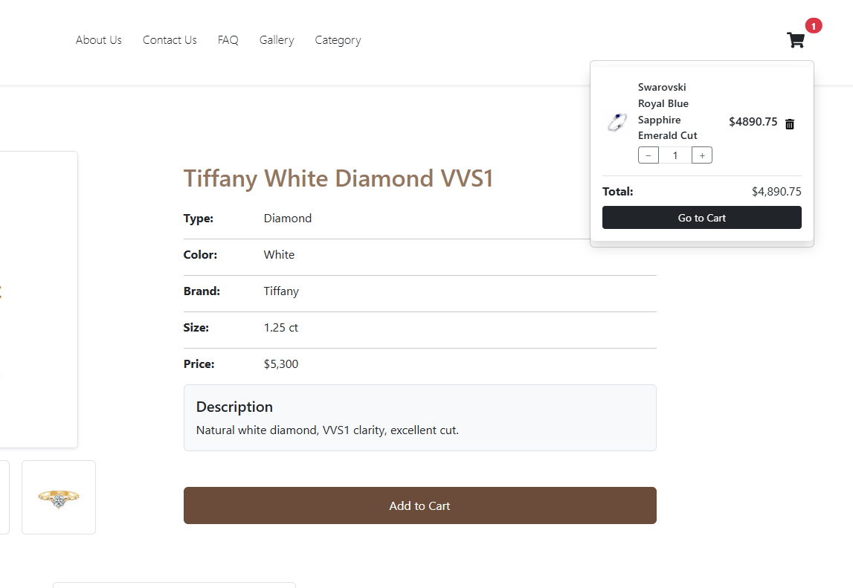

*Picture 14. Screenshot website click the basket.*

* **Cart:**

Click “Go to Cart” to relocate the Cart.

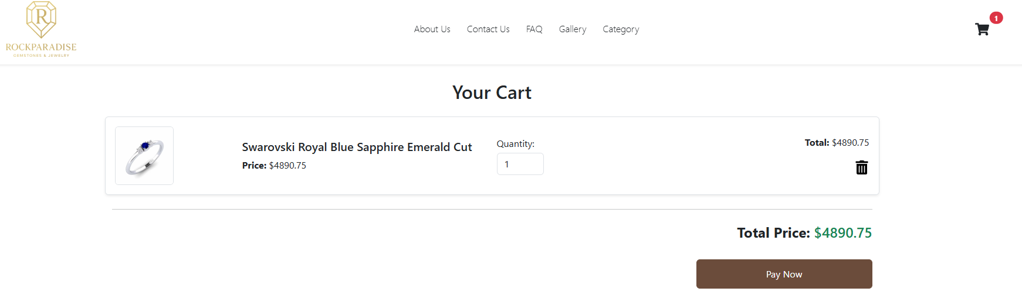

*Picture 15. Screenshot website click “Go to Cart”*

* **Payment detail:**

Fill the form then click “Confirm Payment”

After Confirm you will receive a Successful notification

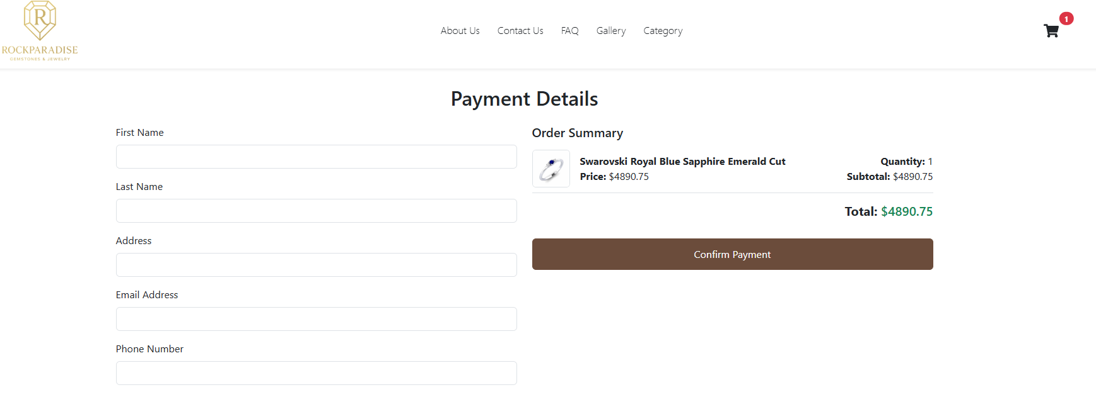

*Picture 16. Screenshot website Payment detail.*

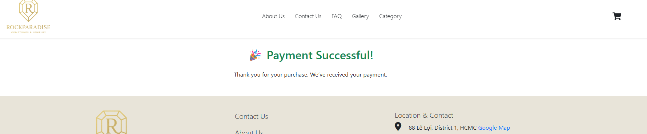

*Picture 17. Screenshot website Payment Successful*

* **Responsive:**

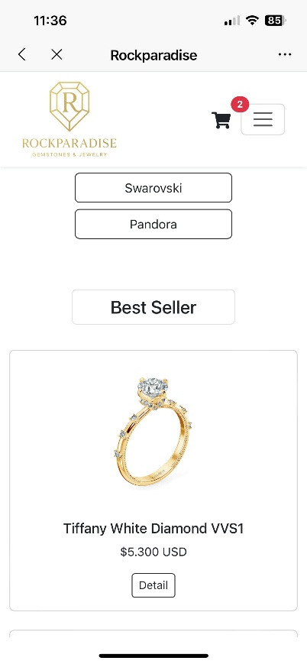

*Picture 18. Screenshot website mobile version*

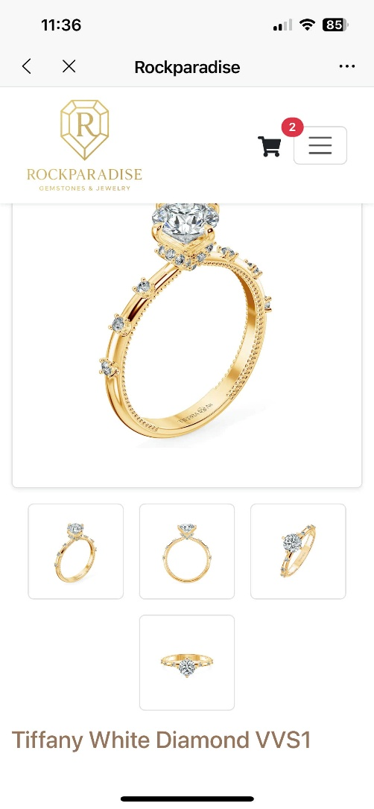

*Picture 19. Screenshot website mobile version*

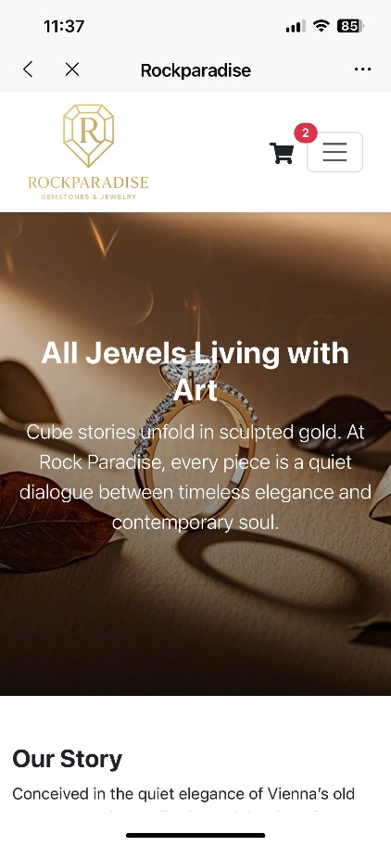

*Picture 20. Screenshot website mobile version*

**Task sheet review 3**

|  |  |  |  |  |  |  |  |
| --- | --- | --- | --- | --- | --- | --- | --- |
| **Project Ref. No.:**  **eP/Advertisement Portal Management**  **System/01** | | **Project Title:** | **Activity Plan Prepared By:** | **Date of Preparation of Activity Plan:** | | | |
| **Sr.**  **No.** | **Task** | **Actual**  **Start**  **Date** | **Actual Days** | **Team**  **Mate Names** | **Status** |
| 1 | Homepage | ROCK PARADISE | Thien Tan | 02/08/2025 |  | Tan | Completed |
| 2 | Category | 02/08/2025 |  | Tan | Completed |
| 3 | Viewmore | 02/08/2025 |  | Tan | Completed |
| 4 | Payment |  |  | 02/08/2025 |  | Tan | Completed |
| 5 | Cart |  |  | 02/08/2025 |  | Tan | Completed |
| 6 | About us |  |  | 02/08/2025 |  | Huy | Completed |
| 7 | Contact us |  |  | 02/08/2025 |  | Huy | Completed |
| 8 | Faq |  |  | 02/08/2025 |  | Huy | Completed |
| 9 | Gallery |  |  | 02/08/2025 |  | Tuan | Completed |
| 10 | Java Script |  |  | 02/08/2025 |  | Tan | Completed |
| 11 | Responsive |  |  | 02/08/2025 |  | Tan | Completed |
| 12 | Json |  |  | 02/08/2025 |  | Tuan | Completed |
|  |  |  |  |  |  |  |  |

|  |  |
| --- | --- |
| **Date:** | |
| Signature of Instructor:  **Ms. Le Mong Thuy** | Signature of Team Leader:  **Tang Thien Tan** |